Test Document
for
Progressive Web Application for Multi-Protocols Gateway Internet of Things
Version 1.0
Prepared by Jauzak Hussaini W, Jonathan
Universitas Indonesia
December 10, 2019
IEEE Standard for Software Test Documentation
(ANSI/IEEE Standard 829-1983)

Test Document Identifier:
- TD-01

Introduction
This chapter defines testing phase of the Progressive Web Application for Multi-Protocols Gateway Internet of Things software development. Software Testing and Hardware Testing was conducted to ensure the product are properly-built and well-functioned.

Test Items
- Software Testing:
- PWA Test
- Black Box Test
- Usability Test.
- Hardware Testing:
- Transmission Time Test and PDR Test.

Features to be Tested
- Transmition-Receive Data
- Progressive Dashboard

Features Not to Be Tested
- There are no feature from the product function to not to be tested

Test Approach or Plan
- PWA
We plan to test the PWA using Google Chrome Lighthouse 5.7.0. Lighthouse is an open-source, automated tool for improving the performance, quality, and correctness of web apps. When auditing a page, Lighthouse runs a barrage of tests against the page, and then generates a report on how well the page did. We also plan to test the load time of each page in 100 iterations between the PWA and non-PWA page. The test plan of Lighthouse are described in Table 1.
Table 1 PWA test plan
No | Criteria | Test | Description
1 | Fast and reliable | Page load is fast enough on mobile networks | A fast page load over a cellular network ensures a good mobile user experience.
2 | Fast and reliable | Current page responds with a 200 when offline | If you're building a Progressive Web App, consider using a service worker so that your app can work offline.
3 | Fast and reliable | start_url responds with a 200 when offline | A service worker enables your web app to be reliable in unpredictable network conditions.
4 | Installable | Uses HTTPS | All sites should be protected with HTTPS, even ones that don't handle sensitive data. HTTPS prevents intruders from tampering with or passively listening in on the communications between your app and your users, and is a prerequisite for HTTP/2 and many new web platform APIs.
5 | Installable | Registers a service worker that controls page and start_url | The service worker is the technology that enables your app to use many Progressive Web App features, such as offline, add to homescreen, and push notifications.
6 | Installable | Web app manifest meets the installability requirements | Browsers can proactively prompt users to add your app to their homescreen, which can lead to higher engagement.
7 | PWA Optimized | Redirects HTTP traffic to HTTPS | If you've already set up HTTPS, make sure that you redirect all HTTP traffic to HTTPS in order to enable secure web features for all your users.
8 | PWA Optimized | Configured for a custom splash screen | A themed splash screen ensures a high-quality experience when users launch your app from their homescreens.
9 | PWA Optimized | Sets a theme color for the address bar. | The browser address bar can be themed to match your site.
10 | PWA Optimized | Content is sized correctly for the viewport | If the width of your app's content doesn't match the width of the viewport, your app might not be optimized for mobile screens.
11 | PWA Optimized | Has a <meta name="viewport"> tag with width or initial-scale | Add a `<meta name="viewport">` tag to optimize your app for mobile screens.
12 | PWA Optimized | Contains some content when JavaScript is not available | Your app should display some content when JavaScript is disabled, even if it's just a warning to the user that JavaScript is required to use the app.
13 | PWA Optimized | Provides a valid apple-touch-icon | For ideal appearance on iOS when users add a progressive web app to the home screen, define an `apple-touch-icon`. It must point to a non-transparent 192px (or 180px) square PNG.

- Black Box
Black box testing is a method of software testing that examines the functionality of an application without peering into its internal structures or workings. There are four test plan regarding black box testing. These test plans are described in Table 2
Table 2 Black box test plan
No | Test Case ID | Description | Procedure | Input | Expected Output
1 | TC-1 | Open home page from a desktop | - Open browser using desktop  - Go to IoT-MPG website | - | Page responsively loaded conform to device resolution
2 | TC-2 | Open home page smartphone | - Open browser using smartphone  - Go to IoT-MPG website | - | Page responsively loaded conform to device resolution
3 | TC-3 | Open dashboard page from desktop | - Open browser using desktop  - Go to IoT-MPG website  - Open dashboard page | - | Page responsively loaded conform to device resolution, data fetched in realtime
4 | TC-4 | Open dashboard page from smartphone | - Open browser using smartphone  - Go to IoT-MPG website  - Open dashboard page | - | Page responsively loaded conform to device resolution, data fetched in realtime

- Usability
IoT-MPG usability testing was carried out using questionnaire method. This questionnaire consists of ten different statements, with comparison between positive and negative statements is 5:5. The form of questions is multiple choice by using a variable measurement scale that refers to a Likert scale, where each is made using a scale of 1-5 answer categories (Strongly Disagree, Disagree, Neither Agree nor Disagree, Agree, Strongly Agree). The initial step in calculating the usbility questionnaire is to add up the value of each statement. Statements with odd number sequences, can be calculated using formulas (scale - 1). Whereas, for an even sequence of statements, it can be calculated by the formula (5 - scale), where the scale is a number on the likert scale chosen by the respondent. The sum of each statements value then being multiplied by 2.5 to get 100 maximum score for each respondet. Final score of the test is the average score of all respondents score.
The test subject is a random picked user. Six respondents were taken from the test subjects to conduct usability testing. The six respondents will run the application and then fill out the questionnaire provided. The question regarding usability test are described in Table 3.

Table 3 Usability test questionnaire
No | Question
1 | I think that I would like to use this system frequently.
2 | I found the system unnecessarily complex.
3 | I thought the system was easy to use.
4 | I think that I would need the support of a technical person to be able to use this system.
5 | I found the various functions in this system were well integrated.
6 | I thought there was too much inconsistency in this system.
7 | I would imagine that most people would learn to use this system very quickly.
8 | I found the system very cumbersome to use.
9 | I felt very confident using the system.
10 | I needed to learn a lot of things before I could get going with this system.

- Transmission Time and Packet Delivery Ratio
The gateway will receive data from all four communication protocols then store it in local pool database. The data transmission is iterated for 1000 times. The transmition time and packet delivery ratio of each protocol communication will be analyzed using python script running on the gateway.

Item Pass/Fail Criteria
- Software Pass Criteria
There are three major criteria regarding software pass-fail criteria. These are PWA test pass-fail criteria, black box test pass-fail criteria, and usability test pass-fail criteria.
For PWA test pass-fail criteria, the application will pass PWA test if posess three criteria mentioned by Google Lighthouse and pass thirteen google lighthouse test plan described at Table 1, including offline capability since the second visit of the website.
For black box test pass-fail criteria, the application will pass black box test if the test plan pass all black box test plan described at Table 2.
For usability test pass-fail criteria, the application will pass usability test if scored more than 70 (Acceptable) or between 50-70 (Marginal) in usability questionnaire score mentioned at Table 3.

- Hardware Pass Criteria
The application will pass hardware test if:
- Four nodes from each protocol successfully transmit data and received by the same gateway simultaneously.
- Packet loss is no more than 10 % from each node or Packet Delivery Rate is equal or more than 90%.

Test Deliverables
- Test Tools and Libraries
- Google Lighthouse from Google Chrome
- Page reloader library

Testing Tasks
- Identify tasks necessary to prepare for and perform testing
- Identify all task interdependencies
- Identify any special skills required

Environmental Needs
- Software Test Environment
PWA and Black Box Test was conducted in November 22, 2019, 5:38 PM GMT+7. Device used in the test is Asus A455LB-i5 5200U CPU with Nexus 5X emulated and 4x CPU throttling. Host user agent used is Mozilla/5.0 (Windows NT 10.0; Win64; x64) AppleWebKit/537.36 (KHTML, like Gecko) Chrome/80.0.3970.5 Safari/537.36. Network user agent used is Mozilla/5.0 (Linux; Android 6.0.1; Nexus 5 Build/MRA58N) AppleWebKit/537.36 (KHTML, like Gecko) Chrome/74.0.3694.0 Mobile Safari/537.36 Chrome-Lighthouse. Network throttling conducted at 150 ms TCP RTT, with 1,638.4 Kbps throughput.
- Hardware Test Environment
Transmission and PDR Test was conducted in Dec 8, 2019, 5:38 PM GMT+7. Subject to be tested are one gateway, one WiFi node, one BLE node, one ZigBee node, and one LoRa node.

Responsibilities
Table 4. Responsibilities
No | Test Type | PIC
1 | Software Test | Jauzak
2 | Hardware Test | Jonathan
3 | Software Documentation | Jonathan
4 | Hardware Documentation | Jauzak

Schedule
Table 5. Schedule
Activity | November |  |  |  | December
Activity | I | II | III | IV | I | II | III | IV
PWA Test
Balck Box
Usability Test
Transmission and PDR Test

Risks or Contingencies
- Server might collapse
- Hardware might exhausted

Results
- Software Test
- PWA Test Result
Test result generated by Lighthouse are described in Table 6. We can imply from the table that thirteen out of thirteen test plan giving true result. It means that IoT-MPG application has Fast and Reliable, Installable, and PWA optimized according to Google Lighthouse.
Table 6 PWA Lighthouse test result
No | Criteria | Test | Result
1 | Fast and reliable | Page load is fast enough on mobile networks | True
2 | Fast and reliable | Current page responds with a 200 when offline | True
3 | Fast and reliable | start_url responds with a 200 when offline | True
4 | Installable | Uses HTTPS | True
5 | Installable | Registers a service worker that controls page and start_url | True
6 | Installable | Web app manifest meets the installability requirements | True
7 | PWA Optimized | Redirects HTTP traffic to HTTPS | True
8 | PWA Optimized | Configured for a custom splash screen | True
9 | PWA Optimized | Sets a theme color for the address bar. | True
10 | PWA Optimized | Content is sized correctly for the viewport | True
11 | PWA Optimized | Has a <meta name="viewport"> tag with width or initial-scale | True
12 | PWA Optimized | Contains some content when JavaScript is not available | True
13 | PWA Optimized | Provides a valid apple-touch-icon | True

Repetitive visit was performed on this application when PWA is registered and not registered to proof that PWA is reducing load time. The result then plotted in Figure 1. In 100 iteration visits, non-PWA page averaging 2.34 seconds while PWA averaging only 0.76 seconds. This might happened because all the static content which remains same to an extent all over the application like the basic HTML template, CSS and JavaScript without versioning are stored in local storage by service worker. This content can easily be cached and thus loaded instantly from the cache when the user repeatedly visits them. In Figure 1 we can see that there is a drastic slope between first and second PWA visit. This might happened because service worker are installed after the first load. We aware that due to network inconsistency the load time for non-PWA application might be fluctuating. We also aware that PWA load time might be fluctuating because of local device performance and usage.
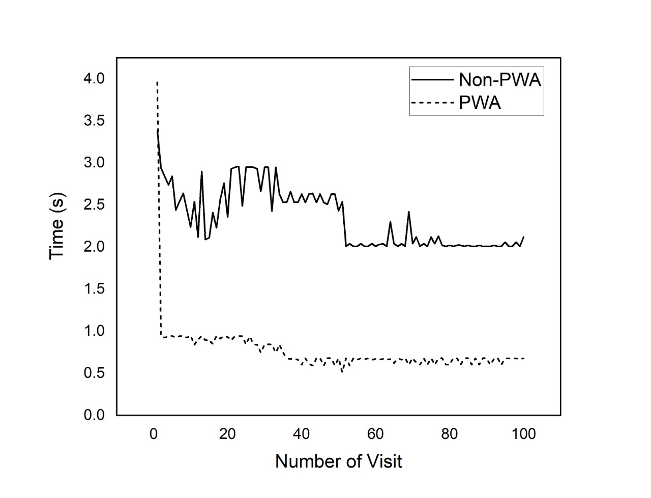
Figure 1 Repetitive visits load time

- Black Box Test Result
Test result regarding black box test are described in Table 7. The test are conducted twice by different tester and giving the same results. From given test case in Table 2, all of them are accepted. It means that the output and expected output are matched, and IoT-MPG application are ready to use in term of functionality.

Table 7 Black box test result
No | Test Case ID | Description | Output | Result
1 | TC-1 | Open home page from a desktop | Page responsively loaded conform to device resolution | Accepted
2 | TC-2 | Open home page smartphone | Page responsively loaded conform to device resolution | Accepted
3 | TC-3 | Open dashboard page from desktop | Page responsively loaded conform to device resolution, data fetched in realtime | Accepted
4 | TC-4 | Open dashboard page from smartphone | Page responsively loaded conform to device resolution, data fetched in realtime | Accepted

- Usability
The questionnaire result are described in Table 8. The result is then calculated using the usability score calculation mentioned in Usability Test Plan.

Table 8 Usability questionnaire answer
No | Respondent | Scale
No | Respondent | Q1 | Q2 | Q3 | Q4 | Q5 | Q6 | Q7 | Q8 | Q9 | Q10
1 | Respondent 1 | 4 | 2 | 4 | 1 | 4 | 3 | 4 | 1 | 4 | 1
2 | Respondent 2 | 4 | 2 | 3 | 1 | 5 | 1 | 4 | 2 | 5 | 2
3 | Respondent 3 | 5 | 1 | 4 | 2 | 5 | 3 | 4 | 1 | 4 | 2
4 | Respondent 4 | 4 | 1 | 5 | 2 | 5 | 1 | 3 | 2 | 4 | 3
5 | Respondent 5 | 4 | 3 | 4 | 1 | 5 | 3 | 5 | 1 | 4 | 2
6 | Respondent 6 | 5 | 3 | 5 | 2 | 5 | 2 | 4 | 2 | 5 | 2

Tabel 9 Usability final score
No. | Respondent | Usability Calculation
No. | Respondent | Q1 | Q2 | Q3 | Q4 | Q5 | Q6 | Q7 | Q8 | Q9 | Q10 | Score
1 | Respondent 1 | 3 | 3 | 3 | 4 | 3 | 2 | 3 | 4 | 3 | 4 | 80
2 | Respondent 2 | 3 | 3 | 2 | 4 | 4 | 4 | 3 | 3 | 4 | 3 | 82.5
3 | Respondent 3 | 4 | 4 | 3 | 3 | 4 | 2 | 3 | 4 | 3 | 3 | 82.5
4 | Respondent 4 | 3 | 4 | 4 | 3 | 4 | 4 | 2 | 3 | 3 | 2 | 80
5 | Respondent 5 | 3 | 2 | 3 | 4 | 4 | 2 | 4 | 4 | 3 | 3 | 80
6 | Respondent 6 | 4 | 2 | 4 | 3 | 4 | 3 | 3 | 3 | 4 | 3 | 82.5
Total Score |  |  |  |  |  |  |  |  |  |  |  | 487.5
Average Score |  |  |  |  |  |  |  |  |  |  |  | 81.25

The calculation result are described in Table 9. Based on Table 9, the average score obtained was 81.25. The average score of 81.25 is included in the acceptable category. This shows that the application is well accepted by end users in terms of usability aspects.

- Hardware Test
Transmission Time and Packet Delivery Ratio tests are conducted in order to test and validate the work of the multi-protocol gateway. Test result are then plotted in Figure 2 and Figure 3.

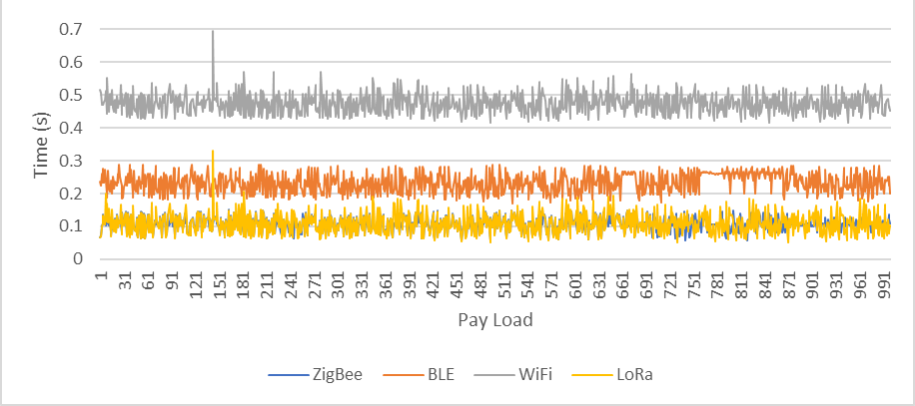
Figure 2 Transmission time
Figure 2 shows the transmission time for each type of communication protocol. In 1000 pay load, ZigBee averaging 0.10 seconds transmit time, BLE averaging 0.23 transmit time, WiFi averaging 0.47 transmit time, and LoRa averaging 0.11 transmit time. The WiFi protocol experiencing largest transmit time because the transmission module used in the node has technical limitation.
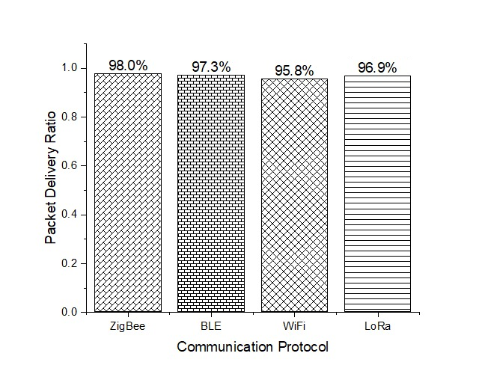
Figure 3 Packet Delivery Ratio of each communication protocol

Figure 3 shows the packet delivery ratio for each type of the communication protocol. The packet delivery rate is 98% for ZigBee, 97.3% for Bluetooth Low Energy, 95.8% for WiFi, and 96.9% for LoRa. The PDR values are considered normal based on the technical specification of the standard and the equipment used.

